**Steps to activate & schedule the exam through SAP Learning Hub Subscription -**

1. Login to <https://learning.sap.com/> with UID (Universal ID i.e. cognizant email address) and select the account (**SID/PID**) to which SAP LH has been assigned. (Check for mail from [**idservice@notifications.sap.com**](mailto:idservice@notifications.sap.com) for “Learner ID” i.e. SID/PID to login & activate the SAP learning hub access.
2. Once logged in click on the profile icon & then on“My Account” option. Click & sign in to link the Secondary personal (gmail/yahoo) email address (If not done earlier).

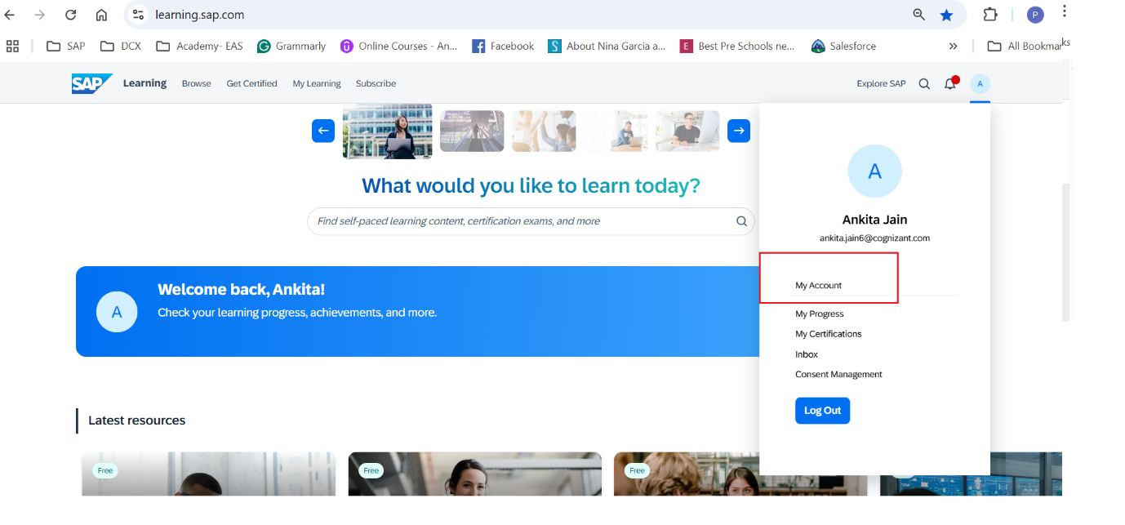

1. Click on “Add Identity” to add the secondary personal email address. Once added & verified you will get to the below screen.

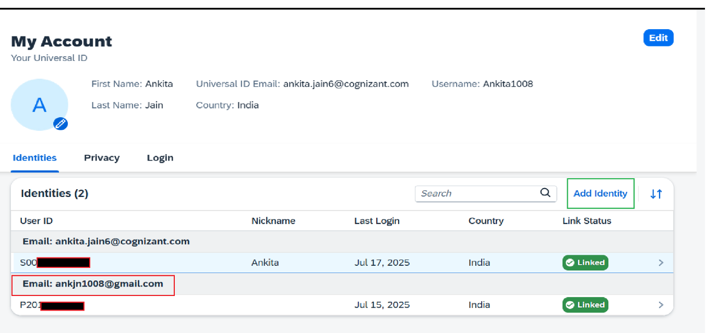

1. Once UID , SID & Personal email address are linked together then, login again to <https://learning.sap.com/> you will be able to see the below screen, click “Go to My Learning”.

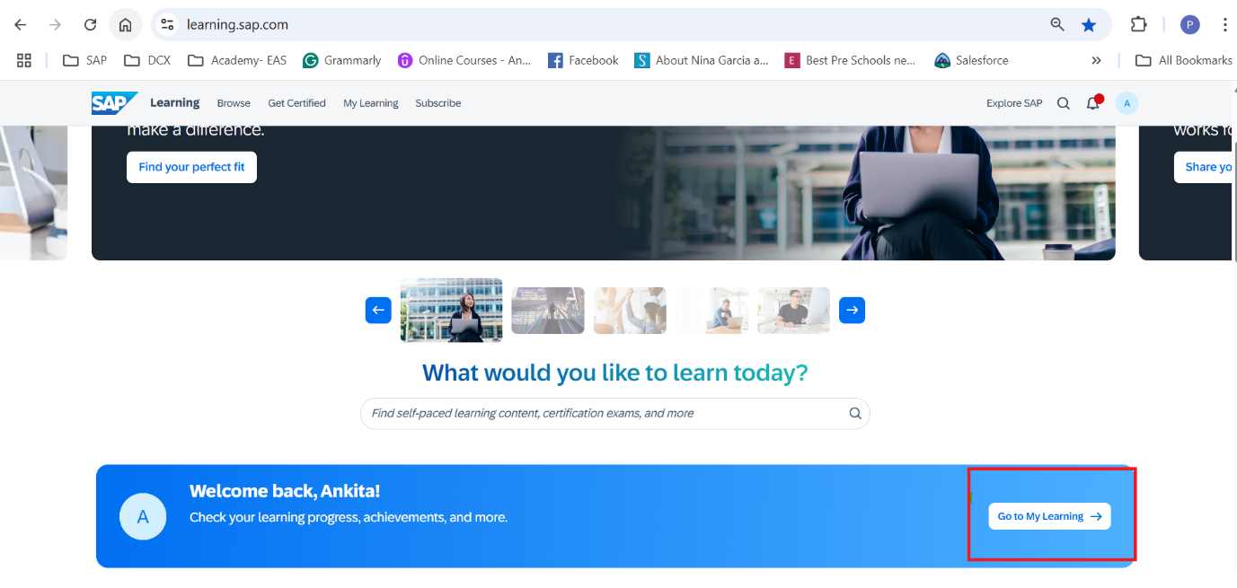

1. Click “**Subscription**” in then left most panel in the below screen.

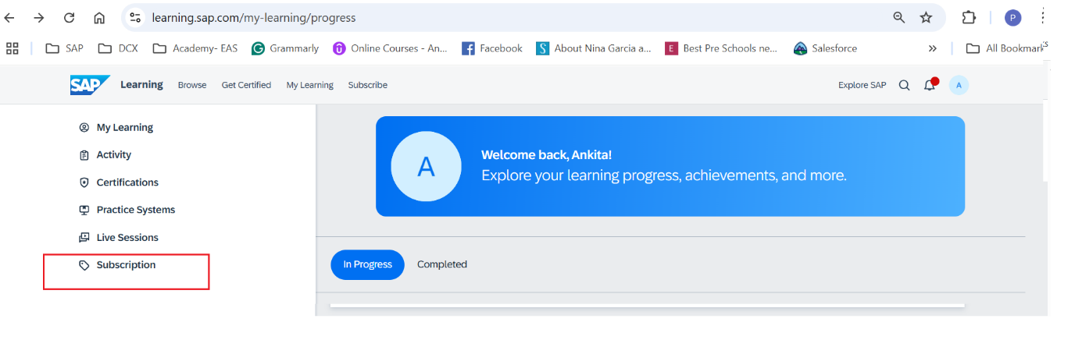

1. After clicking the “**Subscription**” you will get the below screen, which means your learning hub license is activated (**4 Certification Attempts**).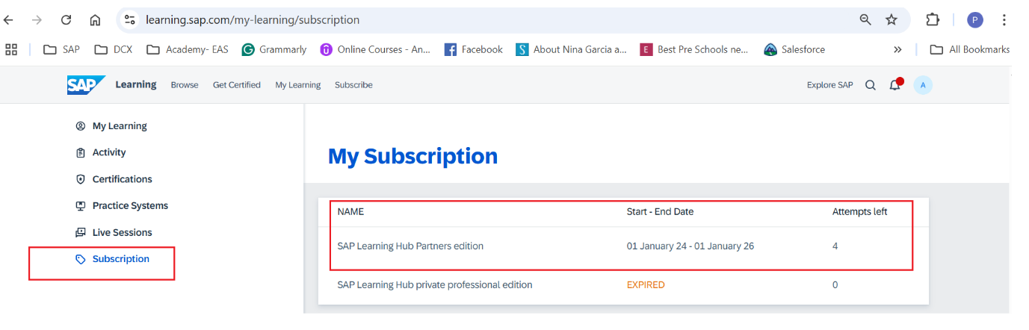
2. Then try to schedule the exam after searching the relevant certification exam ( <https://learning.sap.com/certifications>).
3. Refer the [Step-by-step guide - How to get certified with SAP Certification?](https://learning.sap.com/helpcenter/certification-support/how-to-get-certified) ( Please use **personal laptop** to complete the certification as there is no Co-operate security approval to install the “Question Mark” Software in Cognizant Laptops**).**
4. **Ensure your computer is ready for exam day (**[**https://sapcertification.questionmark.com/700161/ext/certificationhub/**](https://sapcertification.questionmark.com/700161/ext/certificationhub/) **)**

* Ensure you have the following equipment in place before taking your exam:
* Question-mark Secure browser (must be downloaded and installed)
* Webcam
* Microphone or headset
* Broadband connection (at least 2 Mbps download and 2 Mbps upload)
* Prepare your equipment and test your system at least 2-3 hours in advance of taking your exam.